**Model Development Phase Template**

|  |  |
| --- | --- |
| Date | 25 October 2024 |
| Team ID | 739755 |
| Project Title | Bird Species Classification |
| Maximum Marks | 10 Marks |

**Initial Model Training Code, Model Validation and Evaluation Report**

The initial model training for your bird species classification project involves preparing the dataset using Image Data Generator for data augmentation and preprocessing. The CNN model architecture consists of multiple convolutional layers to extract features from images, followed by max-pooling layers to reduce the spatial dimensions Plots of training and validation accuracy, as well as training and validation loss, are created to visualize how well the model learns over time. The model is then saved for future use.You can customize various aspects like the number of epochs, batch size, and model architecture to better suit your dataset and task requirements.

**Initial Model Training Code (5 marks):**

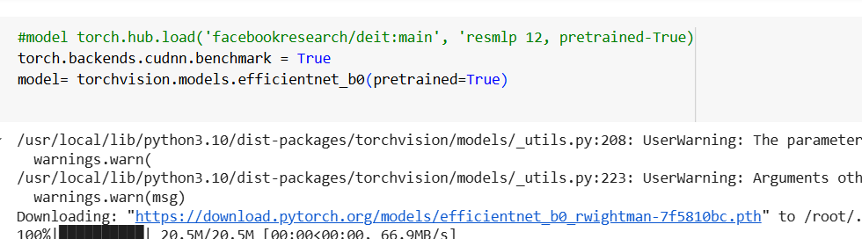

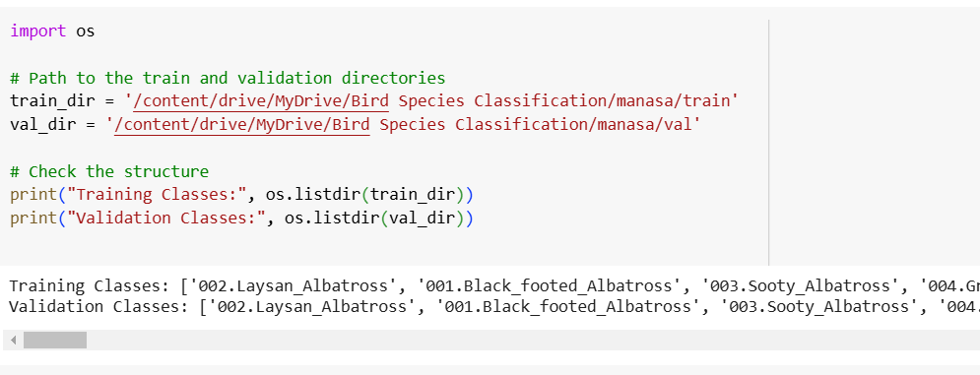

**Model Validation and Evaluation Report (5 marks):**

|  |  |  |
| --- | --- | --- |
| **Model** | **Summary** | **Training and Validation Performance Metrics** |
| **CNN** | A Convolutional Neural Network (CNN) is a deep learning model designed for analyzing visual data, particularly images. It consists of several layers, including convolutional layers, pooling layers, and fully connected layers. The convolutional layers apply filters (kernels) to input images to extract important features, such as edges and textures. Pooling layers reduce the spatial dimensions of the feature maps, helping to reduce computational load and prevent overfitting. After convolution and pooling, the data is flattened into a 1D vector, which is then passed through fully connected layers to make predictions or classifications.  CNNs are highly effective for image recognition tasks because they automatically learn spatial hierarchies of features, making them robust in handling complex image data. The architecture can be customized based on the complexity of the problem, and CNNs are often trained using large datasets to achieve high accuracy. |  |